**Experiment – 6**

**Node.js**

**Server Side Scripting**

Lab assignments to complete this session:

FILE STRUCTURE:

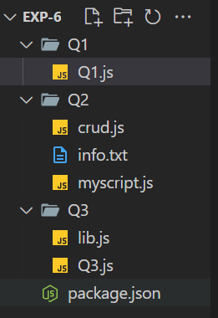

1. To create a Simple Hello World Application using Node js

CODE:

const http = require('http');

const server = http.createServer((request,response)=>

{

    response.end("Hello world\n");

});

server.listen(9000,()=>

{

    console.log("Server is running");

});

OUTPUT:

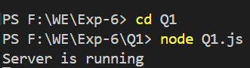

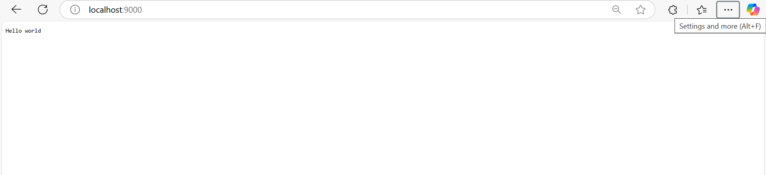

1. To implement CRUD operation using the fs module in node.js

CODE:

const fs = require("fs");

//created directory

// fs.mkdirSync("Q2");

// reads file info and appends

fs.writeFileSync("info.txt","My name is Soham Walam");

fs.appendFileSync("info.txt","\nThis is append file function");

fs.appendFileSync("info.txt","\nThis is next line just for checking");

fs.appendFileSync("info.txt","\nUpdate checking");

//reads data -> buffer

// const data = fs.readFileSync("Soham/info.txt");

//converts to String

// org_data = data.toString();

// console.log(data);

// console.log(org_data);

//renames file

// fs.renameSync("Soham/info.txt","Soham/data.txt");

//Removes file

// fs.unlinkSync("Soham/data.txt");

//remove directory

//fs.rmdirSync("Soham");

**OUTPUT:**

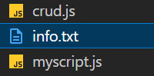

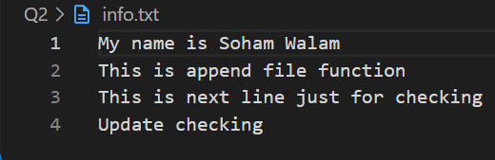

1. **Create a User defined module and ue it in application.**

**CODE:**

**Lib.js**

// lib.js

// Add function

function add(a, b) {

    return a + b;

}

// Subtract function

function subtract(a, b) {

    return a - b;

}

// Multiply function

function multiply(a, b) {

    return a * b;

}

// Divide function

function divide(a, b) {

    if (b === 0) {

        return 'Error: Division by zero is not allowed';

    }

    return a / b;

}

// Power function (a raised to the power of b)

function power(a, b) {

    return Math.pow(a, b);

}

// Square root function

function sqrt(a) {

    if (a < 0) {

        return 'Error: Negative number cannot have a real square root';

    }

    return Math.sqrt(a);

}

// Factorial function

function factorial(n) {

    if (n < 0) {

        return 'Error: Factorial for negative numbers is undefined';

    }

    if (n === 0) {

        return 1;

    }

    let result = 1;

    for (let i = 1; i <= n; i++) {

        result *= i;

    }

    return result;

}

// Absolute value function

function abs(a) {

    return Math.abs(a);

}

// Rounding function (rounds to nearest integer)

function round(a) {

    return Math.round(a);

}

// Exponential function (e^a)

function exp(a) {

    return Math.exp(a);

}

// Logarithm function (natural log of a)

function log(a) {

    if (a <= 0) {

        return 'Error: Logarithm is only defined for positive numbers';

    }

    return Math.log(a);

}

// Export all functions to make them accessible in other files

module.exports = {

    add,

    subtract,

    multiply,

    divide,

    power,

    sqrt,

    factorial,

    abs,

    round,

    exp,

    log

};

**Q3.js**

**// app.js**

// Import the enhanced math module

const lib = require('./lib');  // Import the lib module

// Use the functions from the lib module

// Addition

console.log(`10 + 5 = ${lib.add(10, 5)}`);

// Subtraction

console.log(`10 - 5 = ${lib.subtract(10, 5)}`);

// Multiplication

console.log(`10 * 5 = ${lib.multiply(10, 5)}`);

// Division

console.log(`10 / 5 = ${lib.divide(10, 5)}`);

console.log(`10 / 0 = ${lib.divide(10, 0)}`);  // Division by zero

// Power

console.log(`2^3 = ${lib.power(2, 3)}`);

// Square root

console.log(`Square root of 16 = ${lib.sqrt(16)}`);

console.log(`Square root of -4 = ${lib.sqrt(-4)}`);  // Negative number

// Factorial

console.log(`Factorial of 5 = ${lib.factorial(5)}`);

console.log(`Factorial of -5 = ${lib.factorial(-5)}`);  // Negative number

// Absolute value

console.log(`Absolute value of -7 = ${lib.abs(-7)}`);

// Rounding

console.log(`Round 4.6 = ${lib.round(4.6)}`);

console.log(`Round 4.3 = ${lib.round(4.3)}`);

// Exponential function

console.log(`e^2 = ${lib.exp(2)}`);

// Logarithm

console.log(`Natural log of 10 = ${lib.log(10)}`);

console.log(`Natural log of -1 = ${lib.log(-1)}`);  // Invalid log

**OUTPUT:**

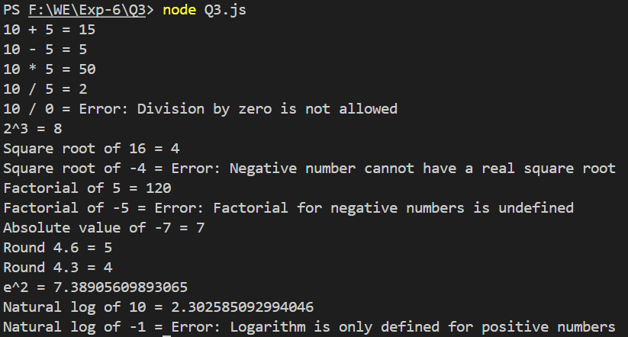

**WRITE UP:**

